- Complete (Doplň):
My Mom
Her name is
She is years old.
My Mom has got hair
and eyes.
Her favourite colour is .
Her favourite food is .

- Translate (Přelož):

My mum is nice,

I like her eyes.

My mum is good,

I love her food.

My mum is funny,

I am her bunny.

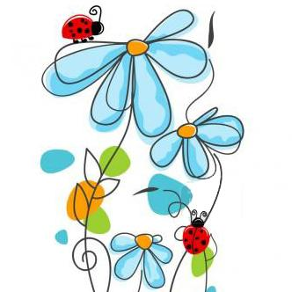
I love mum and mum loves me.

