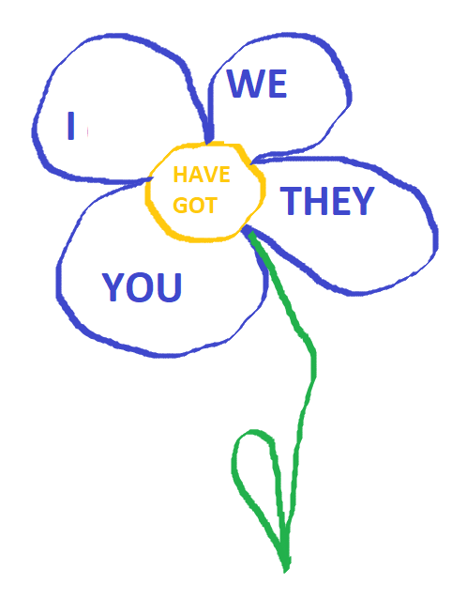
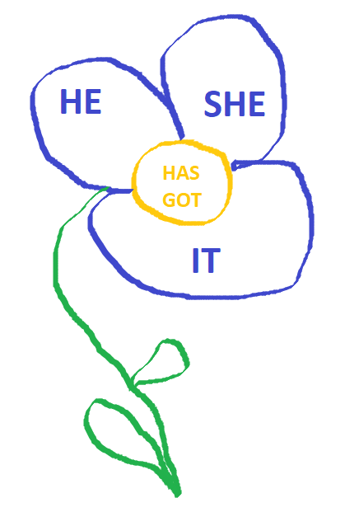

Vymaž tečky a místo nich doplň : „ have got, has got“
- Kate ……………………………………a brother.
- I ………………………………………...two sisters.
- We ……………………………………. a cat.
- You ……………………………………..my computer.
- John and Peter ……………………mobile phones.
- Michal…………………………………a dog.
- A monkey …………………… a banana.

